FINAL REPORT: ATV DESIGN AND COMPETITION

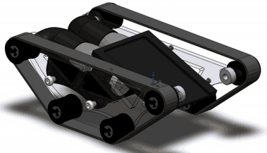

Team Black Widow
Meghan McCarthy, Ishan Chatterjee, Sergio Morales
Engineering Sciences 51
December 13, 2013

ABSTRACT

ASSIGNMENT

The final lab of ES51 involved designing, building, and testing a small All-Terrain-Vehicle under time and monetary constraints. The ultimate goal of the lab was to create an ATV that could complete an obstacle course during a final, capstone competition of the class. The competition involved racing through five obstacle areas testing torque, agility, clearance, compactness, and power. We were given one month, fifty dollars, and a few provided parts to completely design and fabricate our vehicle. Each ATV was to consist of at least one part machined from a laser cutter, a 3D printer, and a CNC mill. With these objectives and limitations in mind, we aimed to build a simple, lightweight, but durable mini ATV that would conquer the course.

THE VEHICLE

Because we only had one month for our project, we opted with a heavily calculated but simple design. Because we put much thought into the initial design, our final design remained relatively unchanged. We designed a tank tread system for our ATV in order to increase traction and agility. We went with a direct-transmission motor system using only the gearboxes already provided with the drill to eliminate the need for external gears and make for a quick fabrication process. The two electric screwdrivers directly powered the small back wheels, but the tread system enabled the transfer of this power to all other wheels. Because we wanted to make our vehicle as lightweight as possible, we used a minimal number of parts and tried to eliminate as much material as possible while still maintaining stability and strength. Thus, our ATV featured a lightweight motor case, a simple two-plate chassis, and a thin angled tray for carrying the block up the ramp.

DESIGN SPECIFICATIONS

SPECIFICATION SHEET

Specification | Value | Units (SI)
Mass | 4.05 | kg
Length | 0.227 | m
Width (including wheels) | 0.157 | m
Height | 0.081 | m
Undercarriage clearance | 0.0126 | m
Turning radius | 0 | m
Drive train gear ratio | 81:1
Steering gear ratio | N/a
No load horizontal speed | 3.09 | m/s

SELF-EVALUATION

FINAL SOLUTION: THE GOOD

For the most part, the final rendering of our ATV came out as expected. The only true constraints we had to work through were the limited time to complete and test the ATV, working with a fifty-dollar budget, and handling the obstacles of the course. Our main objective in this project was keeping the ATV design simple, robust, and compact. We went about completing this goal by implementing the following design features:

- Utilizing the provided 90° gearbox
- Utilizing tank treads
- Eliminating any external gearing
- Designing an integrated motor cover/chassis
- Ensuring an overall modular design

We chose a 90° gear box for our design because it was manufactured and therefore very well-toleranced, reliable, and robust. Also, the gearbox was already in our possession, eliminating time and financial cost. We went with tank treads as opposed to wheels because it eliminated the need for a separate drive train; with treads, only one wheel needed to be powered on each side in order to communicate the power to the rest of the wheels. These first two design choices allowed us make the car extremely compact and lightweight. Furthermore, it drastically simplified our design by allowing us to eliminate external gears, one of the biggest headaches of many groups. Without additional gears, we did not have to worry about support structures to ensure proper gear meshing or losses in efficiency of the drivetrain system. To gain the torque needed to complete the course (especially the ramp) we used smaller wheels. The tread system allowed us to recreate the performance of a large wheel by placing our smaller wheels in any desired configuration. Our fourth part—an integrated motor cover/chassis system—was key in reducing both space and weight, as the motor cover actually served as the chassis. We created a modular design that allowed us to assemble and disassemble our entire vehicle in a matter of five minutes. An important motivation for modularity was the ability to change out the chassis—a component we ensured was laser-cut as opposed to machined. We were very limited in time, and we knew that rapid iterations would be needed when redesigning the hole tolerances, the placement of axles and drive components, etc. These five design features were definitely beneficial, as they ensured an extremely lightweight but strong ATV product.

FINAL SOLUTION: THE BAD

Although we did complete our goals of creating a simple, robust, and compact ATV, we realize that there are disadvantages to some of our design choices. Eliminating additional gears from our design was definitely a risky choice, as we could not drastically change the gear ratio if the vehicle did not have enough torque. We could change the size of the drive wheel to increase the torque, but this still would not generate as much torque as changing the gear ratio of a set of external gears. Another flaw in our design was choosing to power the back-wheels instead of the middle wheels; the back of the vehicle carries a lot of weight from the gearbox and motor components, which shifts the center of gravity backwards. We could improve on this weakness by powering a different wheel, perhaps a more centrally-placed wheel. Ultimately, come competition day, neither of these risky design choices drastically affected the performance.

- DESIGN PROCESS

The design process consisted of brainstorming, selecting a concept, creating a foam core model, running through calculations, making a SolidWorks assembly, and sharing our ideas with others. These preliminary steps were crucial to our project, as they provided us with a chance to weigh the good and bad of different designs and also communicate our ideas to classmates and TFs.

BRAINSTORMING

Before all else, our team met to discuss several ATV designs and the possible directions we could take with our vehicle. We shared ideas from our experiences with childhood remote-controlled cars to our knowledge of vehicles on the market today. The sample ATVs from last year’s competition were also helpful during the brainstorming process, especially in illustrating real implementations of wheels and treads. We used both our background knowledge and ideas from the example ATVs to create three possible designs:
Figure 1: Early sketches of alternative designs for our ATV.

- Wheels: Using thick, knobby large wheels would allow the vehicle to conquer the obstacles. The problem with this design is that it would require multiple external gears to power all wheels.
- Three-wheel treads: Treads eliminate the need for a separate drivetrain, which can lead to an overall thinner design. As seen in the sketch on the right, there wouldn’t be enough tension or surface area on the middle wheel to be able to power it. Powering another wheel would cause an issue in the weight distribution and maintaining a stable center of gravity.
- Four-wheel treads: Using a four-wheel tread design would eliminate the need for complicated gearing and would be more stable.

CONCEPT SELECTION

As is shown by the above list, our ATV designs became more and more detailed as we continuously built-on and improved the previous design. This does not imply that the designs became increasingly complicated, however. The more we understood both the time limitation and the course expectations, the more we realized the importance of a simple design. That being said, we settled on our final design option. Not only did this design require less parts and assembly time, but it also utilized the most efficient drivetrain mechanism.

FOAM CORE MODEL

The last steps in the preliminary design process included building a foam core model and presenting our final ideas to the class. We knew that the foam core model was an effective way of communicating our design to others, so we spent a great deal of time making the model as realistic as possible. Each component in our ATV model was made to scale, which helped our classmates and TFs understand just how small and lightweight our vehicle would be. The presentation to our classmates was extremely helpful, as they raised concerns about our gear ratio and undercarriage clearance. We kept their questions in mind when finalizing our SolidWorks design and made adjustments as needed.
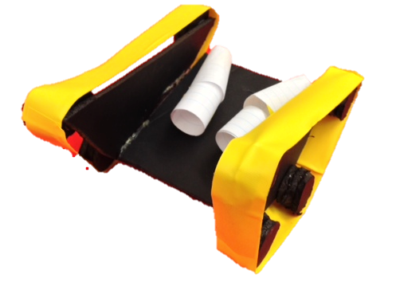
Figure 2: Foam-core model of the tread-design of our ATV.
CALCULATIONS
Once our preliminary design and foam-core model were created, we focused our efforts on calculations. First and foremost, we needed to determine how much torque and power were required to drive up the 22° ramp. From these values, we had to make decisions regarding our gear ratio, wheel size, and dimensions of our vehicle. Because there were so many calculations that had to be done to ensure a running ATV, we created an Excel spreadsheet. This way, we were able to judge our ATV’s performance with different design parameters in mind. Calculations were especially crucial for our ATV because we went with such a risky design.

SOLIDWORKS
After creating rough sketches and more detailed draft sketches, we created our components in SolidWorks. We grouped parts into subassemblies according to their function, which made for a simple redesign process. Finally, we consolidated our work and created a 3D assembly of the entire vehicle to ensure that all components fit together properly. Because we put so much time into the SolidWorks assembly, we found that nearly all of our parts meshed together as planned.

FABRICATION
Once our SolidWorks assembly was complete, we began the fabrication process. Each member focused on one part of the vehicle during a given lab time. We would generally work in the lab at the same time, in case problems, questions, or tasks arose. Because 3D-printing can be such a timely process, we sent out our files for the gear covering and wheels before the second lab meeting; similarly, we ordered the treads for our wheels at this time because of the shipment time. We were able to construct the chassis by the second lab section, as we opted with a laser-cut design. Throughout the fabrication process, we went through 6-7 chassis iterations. Although this consisted of many “re-do’s,” it was not a major issue, as laser-cutting the chassis only took 10 minutes and the modular design was easy to disassemble and reassemble. We tried to limit the amount of parts being milled, as it generally took longer than other machining processes; we only milled our block-holder. Next, we hacksawed and lathed our axle pieces for the drive system. Lastly, we took the two gearboxes from the dissected screwdrivers, as well as our laser-cut controller, and began the soldering process. Once all of our pieces were constructed, we assembled our ATV.

TESTING AND REPAIR
The final step in the design process was testing and repairing our ATV, as needed. Fortunately for us, our ATV handled the track nimbly from the start of testing. Any issues that occurred during testing were largely due to our inexperience driving the vehicle. Thus, we spent more time test-driving than we did repairing our ATV.

- TIME REPORT

CONCEPTUAL DEVELOPMENT

- 9 person hours: We dedicated an entire lab session to brainstorming and selecting a design concept.
- 3 person hours: We met the Friday after lab to design and finalize our foam core.
- 6 person hours: Two members spent the next lab session dimensioning the ATV and running through key calculations.
- 3 person hours: We met after our second lab session to discuss calculations with our TF.
- Total: 21 person hours

SOLIDWORKS AND MASTERCAM
- 3 person hours: One member spent the second lab session creating SolidWorks parts for the motor, motor cover, and chassis.
- 12 person hours: One member spent two full nights on the SolidWorks assembly.
- 6 person hours: We all met for two hours on a Friday to finalize the SolidWorks assembly and prepare the MasterCam code.
- 8 person hours: One member made changes in the design throughout the project.
- Total: 26 person hours

LASER CUTTING, MILLING, LATHING, SOLDERING, AND ASSEMBLING
- 3 person hours: One member laser-cut the two-piece chassis on six separate occasions to perfect the hole dimensions.
- 3 person hours: One member spent three hours milling the block-holder and motor case.
- 3 person hours: One member spent three hours of lab filing and further correcting the motor case.
- 3 person hours: One member spent three hours of lab cutting and lathing the axles to size.
- 1 person hour: One member spent an hour dissecting the electric screwdrivers and fitting them into the casing.
- 8 person hours: One member soldered and wired the controller.
- 36 person hours: We met for 12 hours to finish the assembly.
- Total: 51 person hours

REPAIR AND REDESIGN
- 3 person hours: We met for 1 hour to redesign our block-detachment mechanism.
- Total: 3 person hours

EVALUATION
- 7 person hours: One member spent a day writing the first draft of the lab report.
- 7 person hours: One member spent an afternoon editing and finalizing the lab report.
- 3 person hours: We met for 1 hour to create and practice our final PowerPoint.
- 3 person hours: We met for 1 hour to test our vehicle and practice driving on the track.
- Total: 20 person hours

TOTAL: 130 person hours
- PERFORMANCE

Our ATV performed objectively superbly, garnering 695 points. This was a course record setting performance, however an even better ATV promptly trounced us minutes later! One issue we encountered was that our motors started to underperform over the course of a couple days of testing, cutting our speed and power. Nonetheless, we are very happy with the performance!

MEGHAN
This was hands-down one of the most important engineering experiences I have had at Harvard, and it was a great way to end the class. Not only did I learn how to effectively work on an engineering team, but I also learned just how much goes into designing, fabricating, and testing a product. Fortunately, I was paired with two very hard-working teammates who held similar standards as myself. We all agreed that planning, designing, and investing time early would pay off, and we were certainly right. Aside from our second iteration of 3D-printed wheels, all of our parts were fabricated by Thanksgiving. That being said, we only had to assemble and test our vehicle once back from break. I am glad that we invested so much time in our calculations, SolidWorks assembly, and part construction because it ultimately reduced the amount of time spent redesigning our vehicle. From this project, I learned just how important it is to choose teammates with similar working habits, as well as planning for projects well in advance. I am so happy to have taken this course, as I now know how to design, fabricate, and assemble an impressive end-product.

ISHAN

The ATV project has been an absolute joy. I particularly enjoyed this project because of the open-endedness of the challenge, and thus the emphasis on design. Due of the lack of specified design constraints, the problem can initially seem overwhelming; however, as one examines the course, one can start to form parameters that inform design decisions. Aside from obvious design choices (the car must be smaller than the tunnel, the car must have adequate torque to make it up the ramp, etc.), you can start to think of certain characteristics that you hope would give the ATV an edge of the competition: how can I make the car more nimble, how can I make the car less susceptible to falling over? For us, we wanted to make the robust, most compact, and most modular designs possible. To this end, I think we did very well, making one of the most unique, high-performing ATVs in the competition. Lightweight. No gears. Complete dis/reassembly in 5 minutes. Working on the others on this team has been extremely smooth, and I want to thank them for all their efforts in creating a remarkable ATV.

SERGIO
From the first day of the class I was truly allured by the knowledge and possibilities that this class exposed me to. After learning how to use different machines, optimizing for shapes & materials, and learning how to translate from a virtual design to a physical product this project utilized all the skills that I had recently acquired and pushed me to go beyond them and make autonomous decisions. The ATV design went very well and smoothly due to a cohesive and talented team. We all shared ideas and compromised for the success of the project when necessary. Early on, the team agreed to build a modular tank that was simple, compact, and lightweight. From then on we divided the tasks efficiently according to our strengths. The milling, laser cutting, and machining were all done by separate team members and it was easy to bring all the pieces once each one of us had completed our respective parts. The components of ATV were practically finished before Thanksgiving and once we came back the few parts that needed to be changed were fabricated. Once all the components were ready the car was assembled. At the same time, the controller and the electrical components were wired so that the ultimate ATV was ready by the “driveability” deadline. From then on we made no structural changes and focused on practicing driving on the course. The only downside to having finished with such ample time is that the motors wore down and lost substantial power from then until the day of the competition. We considered switching one of the motors but decided against it since the car was still driving well enough to go around the track nimbly.
In retrospect, the ATV project was by far the most enjoyable engineering I’ve ever had. The process truly taught me how to apply concepts from the surge of a conceptual problem and how to go about designing the best solution (ATV) and proceed to prototype, manufacture, assemble, and correct any design or manufacturing errors that might not have previously been accounted for. All in all, a great team dynamic and constructing a high-performing ATV that we built practically from scratch made this project a true pleasure and something that my teammates and I can be proud.

- VIEWS
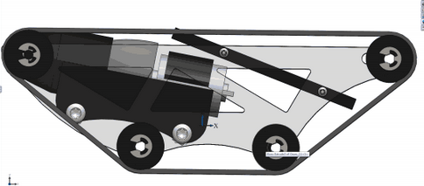
SOLIDWORKS ASSEMBLY

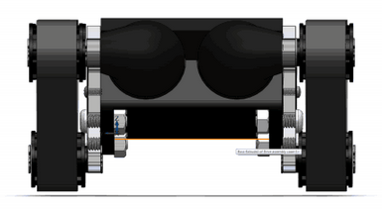

FINAL ATV

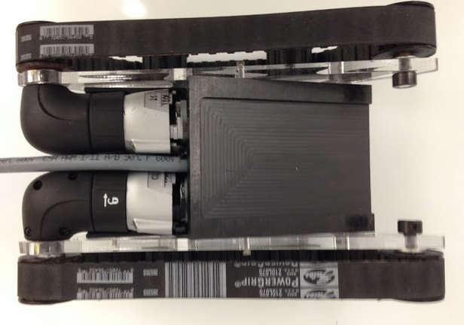

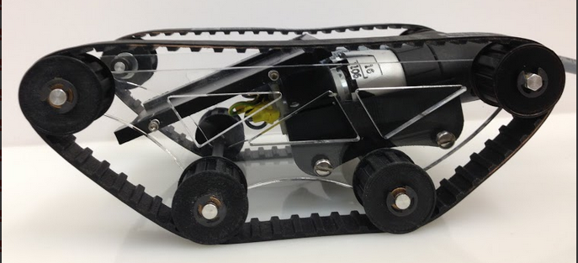

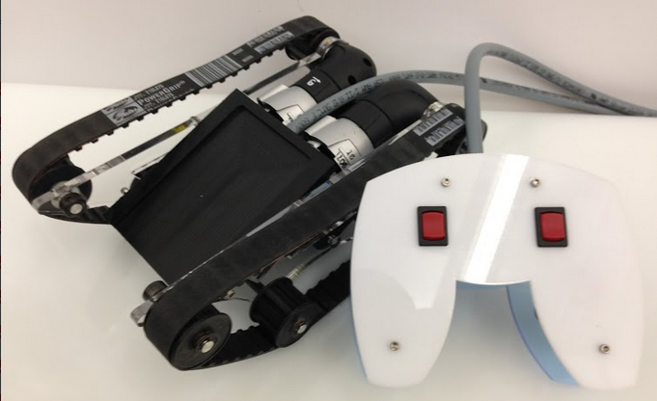
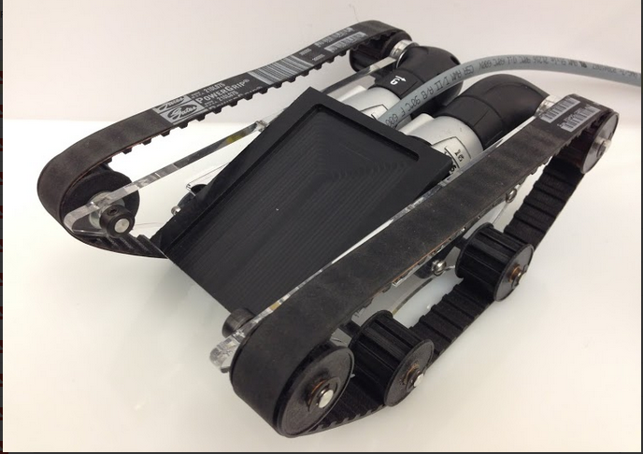

- BILL OF MATERIALS

Part Name | Description | Supplier | Part No.
Chassis | 2, 0.25” Acrylic plates with cut-outs | Custom (laser-cut) | N/a
Wheels | 8, 1” diameter | Custom (3D-printed) | N/a
Motor cover | Acetyl block | Custom (Milled) | N/a
Treads | Trapezoidal Tooth Neoprene Timing Belt, 3/8" Pitch, Trade Size 210L, 21" Outer Circle, 1/2" W | McMaster-Carr | 6484K147
Axle | .25” Aluminum round shaft | Provided
Gearbox | Cordless hand drill gearbox, 81:1 | Skil | N/a
Controller | 2, 0.125” Acrylic plate | Custom (laser-cut) | N/a
Bushings | Oil-Lubricated SAE 841 Bronze Sleeve Bearing  for 1/4" Shaft Diameter, 3/8" OD, 1" Length | McMaster-Carr | 1688K7
Retaining rings | Side-Mount External Retaining Ring (E-Style)  Black-Finish Steel, for 1/4" Shaft Diameter | McMaster-Carr | 97431A300
Hex shaft | .25” Aluminum hex shaft | Provided | N/a
Rear bushings | .25” Delrin sheet | Custom (laser-cut) | N/a
Switch | Large rocker switch | Provided | N/a
Plug | Three prong, male socket | Provided | N/a
Wire | 8 wire core, grey | Provided | N/a
Crimps | Multiple sizes | Provided | N/a
Stand-offs | 1.5” length | Provided | N/a
4-40 screws | 3/8” length | Provided | N/a
¼-20 screws | 5/8” length | Provided | N/a
¼-20 nuts |  | Provided | N/a
¼” shaft collar | Set screw | Provided | N/a
¼” ID washers |  | Provided | N/a

